CPP User Guide for Vendors and Contractors

Downloads

Select the Downloads menu option to view all the proposals that are assigned to future Lettings and have documents available for vendors. When this menu option is selected, the system runs the prequalification checks for the vendor that you are associated with, and displays the appropriate permissions for each document.
- Documents with the cloud icon, can be clicked to download with no further steps required

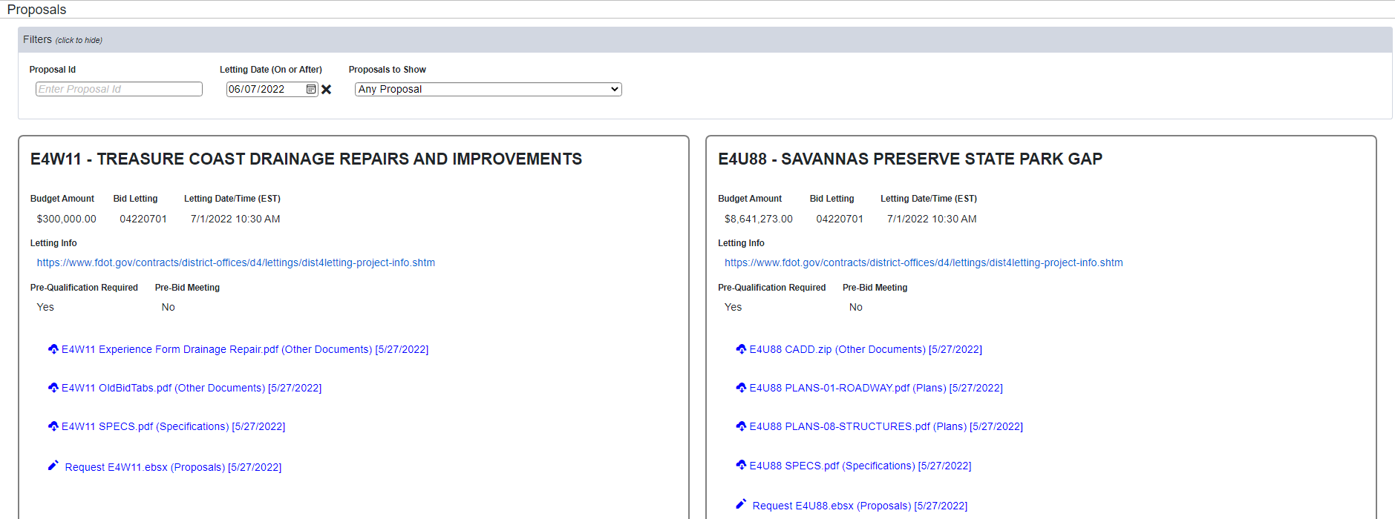

- If the document has the pencil icon then you cannot download it at this time
  - Click on the document to view the reason your vendor is not eligible to download the document
  - Click on Request to submit a request to the Contracts Office to review and approve or deny your request
    - You will receive an email notification of the decision

Users

Users that have the Vendor Admin role may select the Users menu option to view all the authorized users for your organization.
  - Click on the to remove a user from your organization
  - Click on the pencil to change a user’s status from Active to Inactive, or to assign another user the Vendor Admin role
    - There can be only one Vendor Admin at a time

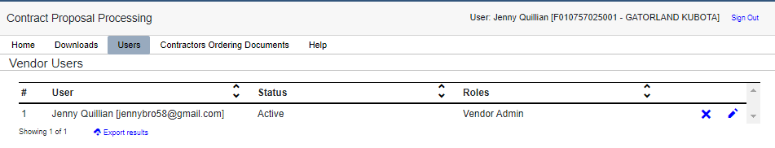
Vendor Name

Contractors Ordering Documents

Click on the Contractors Ordering Documents menu option to generate and download a report of the contractors that have downloaded or requested document for each proposal within a selected Letting ID.

